* PROJECT TITLE

Untitled Stealth Game

* TEAM NAME

Retro Gecko

* TEAM ADVISOR

Ashley Cheema

* PROJECT OVERVIEW
  + Brief description of the project in terms of its overall purpose/scope
  + The purpose of this project is to create a well-polished stealth game that is fun to play.
* TEAM MEMBER ROLES
  + Ian Hudson - Programmer
  + Lysander Foster – Designer
  + Jess Barret – Designer
  + James Barret – Designer/Programmer
  + Jamie Laurence – Web/Programmer/Designer
* KEY DELIVERABLES
  + A statement of the intended submission elements
* PROJECT GOALS
  + This will depend very much on the type of project you are developing
    - Hacking Puzzle
    - Stealth
    - Enemy AI
    - Distractions
    - Sight (Hidden in shadows)
    - Sound (Create distractions)
* TARGET AUDIENCE
  + People who are interested in stealth games. As the enemies are robots it could likely have a lower age rating then other stealth games
* DELIVERY PLATFORMS
  + Currently the game is being developed for PC but as a stretch goal implementing it onto console could be considered
* SOFTWARE REQUIREMENTS
  + Unity
  + 3ds Max
  + Photoshop
  + Visual Studio
  + Brackets
* UX
  + Give details of user experience paradigms to be utilised
* RESOURCES & CONSTRAINTS
  + List of IT equipment to use (if any)
  + List of limitations that may be imposed (if any)
* SCHEDULE Of ACTIVITIES
  + An outline schedule for the work to be done/brief statement of the stages and timing of the work required
* 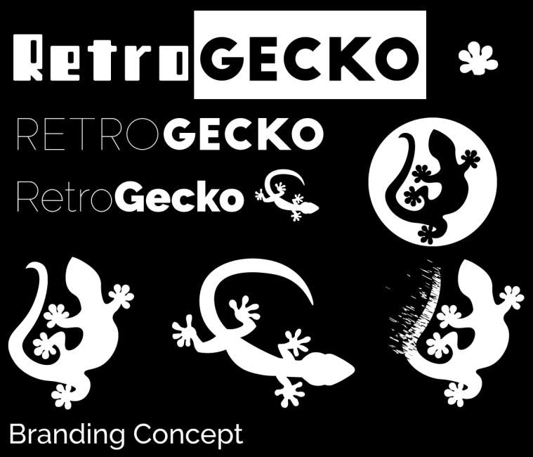APPENDICES

